***LAB 10***

***Exercise 01***

***Q1) shows how to plot more than one line by passing multiple x,y pairs to the plot function. Define y1***

***and y2 as sine waves with a phase shift.***

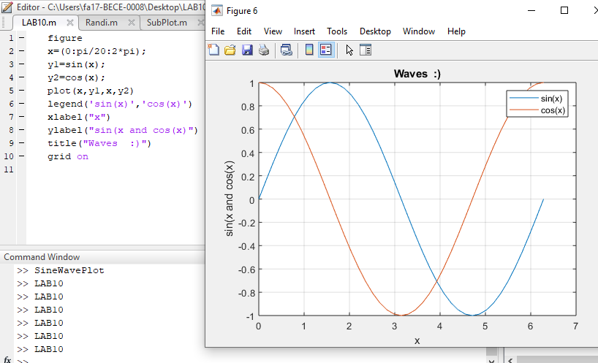

***Q2) shows how to plot two sine waves with different line styles by adding a line specification string to***

***each x,y pair. Plot the first sine wave with a dashed line using &#39;--&#39;. Plot the second sine wave with a***

***dotted line using &#39;:&#39;. (hint : plot(x,y1,;--;,x,y2;:;))***

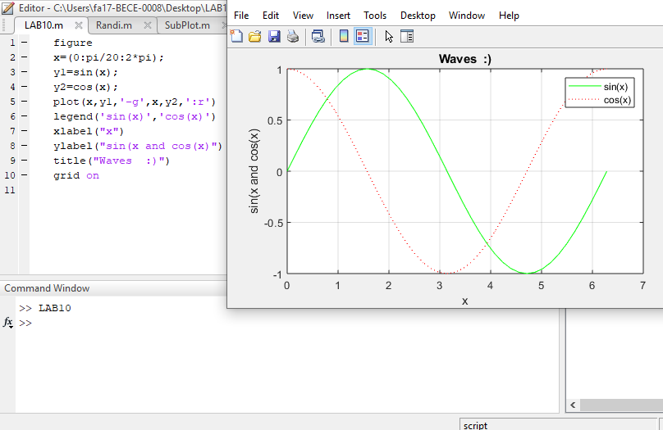

***Q3) shows how to plot two sine waves with different line styles by adding a line specification string to***

***each x,y pair. Plot the first sine wave with a dashed line using -g Plot the second sine wave with a***

***dotted line using :r elements of the line specification strings can appear in any order.***

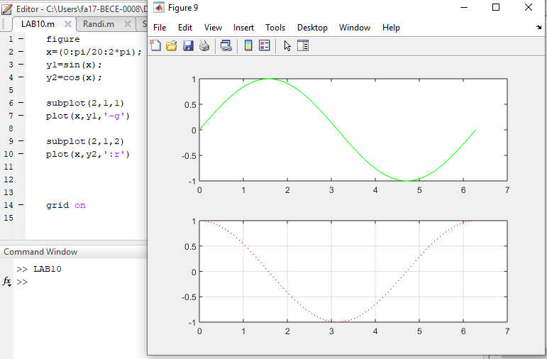

***Exercise 02***

***Be sure that the screen shows all three parts:***

***1) The Script (.m) file.***

***2) The Command Window, showing that you ran the Script file.***

***3) The Plot Window, showing the plot.***

